

Project - Professional Shop Outlet (PRO)

Steve Carroll, Brandon Couts, Garry Cronyn

Group 2 - Scope Management Plan

Saturday June 07, 2014

# Version

|  |  |  |  |
| --- | --- | --- | --- |
| Ver # | Author | Date | Information |
| 4 | **Brandon Couts** | 06/06/2014 | Document Merge, and revision |
| 3 | **Garry Cronyn** | 06/05/2014 | UCD, Scope Form |
| 2 | **Steve Carroll** | 06/05/2014 | MOV, DSC |
| 1 | **Brandon Couts** | 06/05/2014 | Document Creation, Scope Change, Scope Description |

Table of Contents

Version 2

Team Name 4

Team Members 4

Case Area 4

Project Name 4

Executive Summary 4

Measureable Organizational Value 5

Desired Areas of Impact 5

Project IT-Value 5

Measuring Metric 6

MOV Time Frame 6

MOV Summary 6

Deliverable Structure Chart 7

Use Case Diagram 8

Scope Change Process 9

Scope Change Log 9

Scope Change Request Form 9

# Team Name

PluggedIn

# Team Members

|  |  |  |  |  |
| --- | --- | --- | --- | --- |
| Steve Carroll |  | Brandon Couts |  | Garry Cronyn |
| *Scarrol@knights.ucf.edu* |  | *carbondonuts@knights.ucf.edu* |  | *Gcronyn@knights.ucf.edu* |

# Case Area

Pro Shop

# Project Name

Professional Shop Outlet (PRO)

# Executive Summary

PluggedIn has been contracted to build an inventory management system and web store for the **Cypress Garden Golf Academy** Pro shop. This document will expand on the proposed solution and more closely detail the potential the costs related to this operation. The expressed goal of the project is to build a system that allows students access to golf equipment with more efficiency, overall reducing the management requirements and allowing more ease of access for the students and other customers of golf equipment. The pro shop also isn't just a facility but a tool to show that **CGGA** has some of the most up-to-date technologies, professionals, and equipment in the world.

# Measureable Organizational Value

## Desired Areas of Impact

PluggedIn as a company is focused on making professional, streamlined based web technologies. We at PluggedIn can help **CGGA** by building a website that offers to its users an improved user-experience and a sleek and flowing user interface. The presentation of a website is greatly underappreciated in terms of how much it affects the user. For example, a potential customer will leave a site if it takes longer than 3 seconds to load. (As quoted by Google) This affects the user-experience and the creditability of **CGGA**. Therefore focus on building an improved user experience and providing basic and advanced features increases the value of the project for **CGGA**. In addition to these base requirements the system will also strive to provide functionality that will increase the operational value of the project for the managers of the shop by giving reports and automating inventory management for the store itself. This is overall a part of a strategic impact that pushes to increase the value of the **CGGA** brand. By increasing the academy's presence to the outside world, students, both current and perceptive, will be able to see the impact that a school which offers their students equipment and technologies is a good place to learn at.

## Project IT-Value

The project will improve the IT value of the shop by integrating the inventory management system and the web-based shop so that inventory and purchases will be linked. This will allow simple administration by managers for inventory checking, and replacement. Customers will be able to see what is in stock in real time, order equipment and have it ready for an in person visit or shipped to them via normal shipping practices. They will also be able to check rentable equipment, and their prices. By linking the web store with the item database the shop has incredible ways to expand. Discounts in store could, through the server, be emailed to customers. The shop could link rented equipment to the student database to track equipment per student and more easily allow free rentals, thus over time allowing a future expansion of the project as needed.

## Measuring Metric

While the measurable impact of such a project is difficult to calculate. Its predicted that managers will spend 50% less time managing inventory. The shop will now also be able to handle shipping of golf equipment, which it could not easily do before. Managers of the shop will find the time it takes less time to restock inventory. Purchases will automatically be tracked, pulled up, and be searchable. More time will be left for the managers to manage customer concerns, and stay up to date with the latest golfing trends in equipment. Checkouts will be 25% speedier. Employees need only to scan the item to price check it and add the cost.

## MOV Time Frame

Since the project is split into two systems, the in house and the online presence, the initial in house system will only take an estimated month to setup for integration with the inventory management system. The online presence PRO will take an estimated development of six months until production and an additional six for customer feedback, as well as operational improvements for a total of a yearlong development cycle. This will allow students to benefit from the project as soon as possible and give input to the final website. The initial value of the website, upon announcement and opening, will have a huge spike of web traffic from current students checking out the site with stable increase of the customer base from one month onward; the customer base including people other than students. It is expected that the long term impact is more important however as the shop will affect the credibility and prestige of **CGGA.**

## MOV Summary

PRO is an overall growth to the **CGGA** community. It represents an improved strategic value of providing students access to equipment faster, cheaper, and in a better fashion. The main improvement however will be the efficiency of the pro shop. Check out will be faster as every item will be itemized and stored in a database. This will allow cooperation between the in house system and the website.

# Deliverable Structure Chart

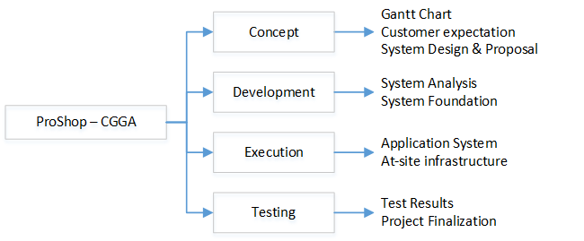

# Use Case Diagram

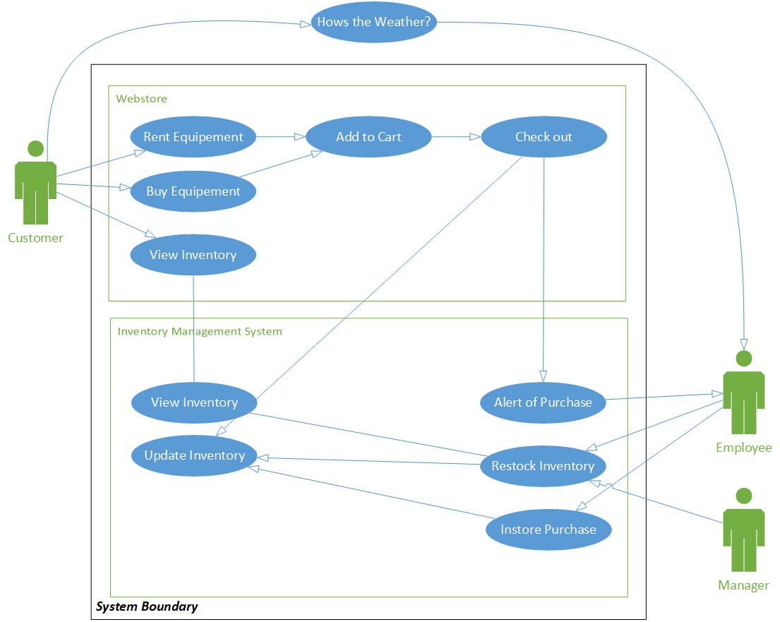

# Scope Change Process

When submitting a scope change request, the request must have all stakeholders approval before edits can be made. Please try and include as much Information as possible to illustrate the changes being made, and the intentions of the changes. Also include the intended benefits of the changes, as well as if the changes are strict or can be modified for additional benefits. Set the indicated priority of the request so that requests can be addressed in proper order.

## Scope Change Log

|  |  |  |  |  |  |
| --- | --- | --- | --- | --- | --- |
| # | Date of Req | Requester | Priority | Progress | Description |
| 1 | 06/07/2014 | A. Eisler | High | Clarify | This is a sample scope change request description:  The scope the project needs to include bananas(?) somewhere in the document for scale. |
|  |  |  |  |  |  |
|  |  |  |  |  |  |

## Scope Change Request Form

|  |  |  |  |
| --- | --- | --- | --- |
| Date: |  | | |
| Requester: |  | | |
| Priority: |  | | |
| Project: | CGGA PRO | | |
| Area: |  | | |
| Description: | | | |
|  | | | |
| Expected Benefit: | | | |
|  | | | |
| Expected Costs: | | | |
|  | | | |
| Signatures: | | | Approved Date: |
|  | |  |  |
|  | |  |  |
|  | |  |  |
|  | |  |  |
|  | |  |  |